- Helm Chart Architecture?
- Helm Chart CLI ?
- First “Hello World ” Helm Chart

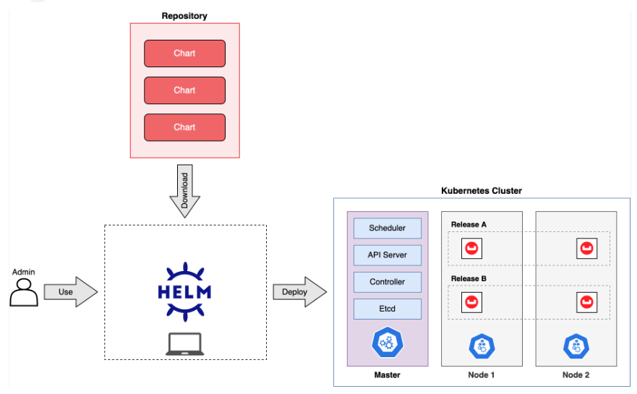

helm create helloworld
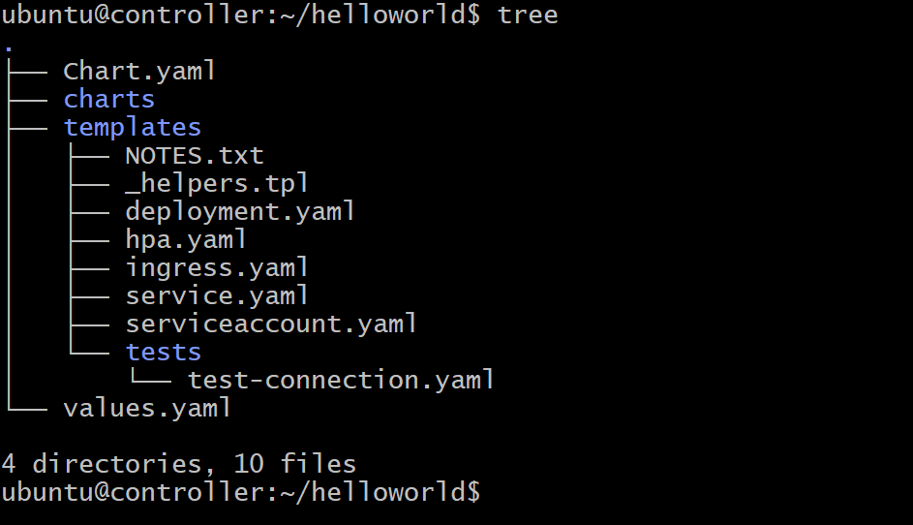

Vi values.yaml
Change
service.type = NodePort
replicaCount=2

helm install myhello-deployment helloworld
Or
microk8s helm3 install myhello-deploy helloworld/

microk8s dashboard-proxy
change http to https

if ur using ec2 instance ubuntu
https:// 54.174.150.156:10443
Login token
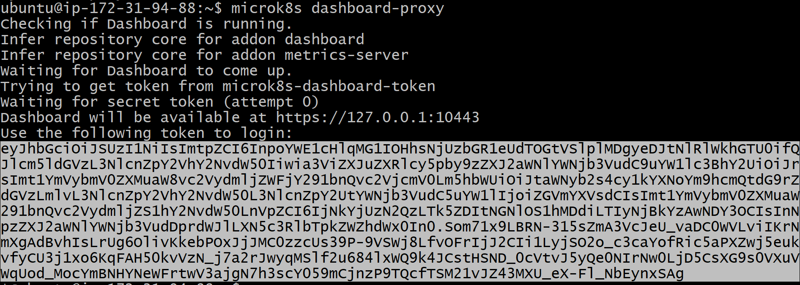

Use this token when browser prompt and asks for key

UNINSTALL:
microk8s helm3 uninstall myhello-deploy --namespace default
0r
helm uninstall myhello-deploy

